|  |  |
| --- | --- |
| EX NO: 07 | FILE INFORMATION APPLICATION |
| DATE : 03-09-19 |

**Aim:**

To write a java program that reads a file name from the user, displays information about whether the file exists, whether the file is readable or writeable, the type of the file and the length of the file in bytes.

**Algorithm:**

**Step 1**: Declare a package fileinfo.

**Step 2**: Declare the class as FileInformation.

**Step 3**: Declare a constructor and add the data members.

**Step 4**: Calculate the size and other information.

**Step 5**: Display the result.

**CLASS DIAGRAM:**

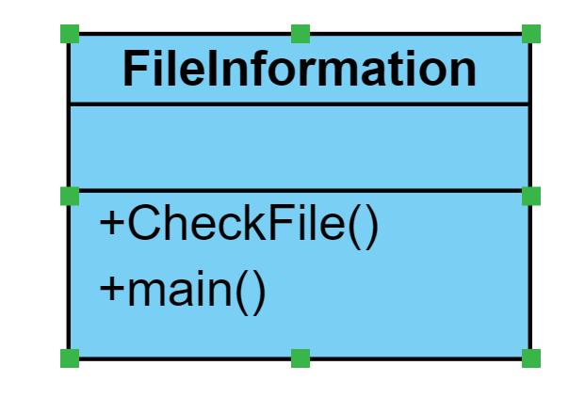

**PROGRAM:**

package fileinfo;

import java.io.File;

import java.util.Scanner;

public class FileInformation {

public void CheckFile()

{

Scanner sc=new Scanner(System.in);

String filename;

File f;

System.out.println("Enter the name of a file with full path:");

filename=sc.next();

f=new File(filename);

if(f.exists()==true)

{

System.out.println("The file exists.");

if(f.canRead()==true)

{ System.out.println("The file is readable");

}

else {

System.out.println("The file is not readable");

}

if(f.canWrite()==true)

{ System.out.println("The File is Writable ");

}

else {

System.out.println("The file is not writable");

}

System.out.println("The length is"+f.length());

}else

{

System.out.println("The file does not exist.");

}

}

public static void main(String[] args) {

FileInformation fi;

fi=new FileInformation();

fi.CheckFile();

}

}

**OUTPUT:**

Enter the name of a file with full path:

/home/user2/EX07-5019.docx

The file exists.

Readable

Writeable

Non-executable

length: 48731

**RESULT:**

Thus the java console application thar reads a file name from user and displays information us verified.